Name: Allan Rodrigues

Class: TE IT A

Roll no: 59

Pid:191104

St. Francis Institute of Technology, Mumbai-400 103

# Department Of Information Technology A.Y. 2021-2022

**Class: TE-ITA/B, Semester: VI**

**Subject: B usiness Intelligence Lab**

Experiment – 5: To implement any one classifier (Decision tree/Naïve Bayes) using any one Language (JAVA/R/Python)

1. **Aim: To implement any one classifier (Decision tree/Naïve Bayes) using any one Language (JAVA/R/Python)**
2. **Objectives: After study of this experiment, the students will be able to Implement Naïve based algorithm**
3. **Outcomes:** After study of this experiment, the students will be able to

**CO 3:** Design and Implement various classification data mining techniques such as Decision tree, Naïve Bayes Regression etc. In addition, apply metrics to measure its performance

1. **Prerequisite: Introduction to all the three classifiers through algorithms & Problem solving approach.**
2. **Requirements: Personal Computer, Windows XP operating system/Windows 7, Internet Connection, Microsoft Word, WEKA tool, Java/R/Python**
3. **Theory:**
   1. **Explain the Classification Algorithm (Decision tree/Naïve Bayes) with example**
   2. **Applications of Classification Algorithms (Decision tree/Naïve Bayes)**
   3. **Advantages and Disadvantages of Classification Algorithms (Decision tree/Naïve Bayes)**

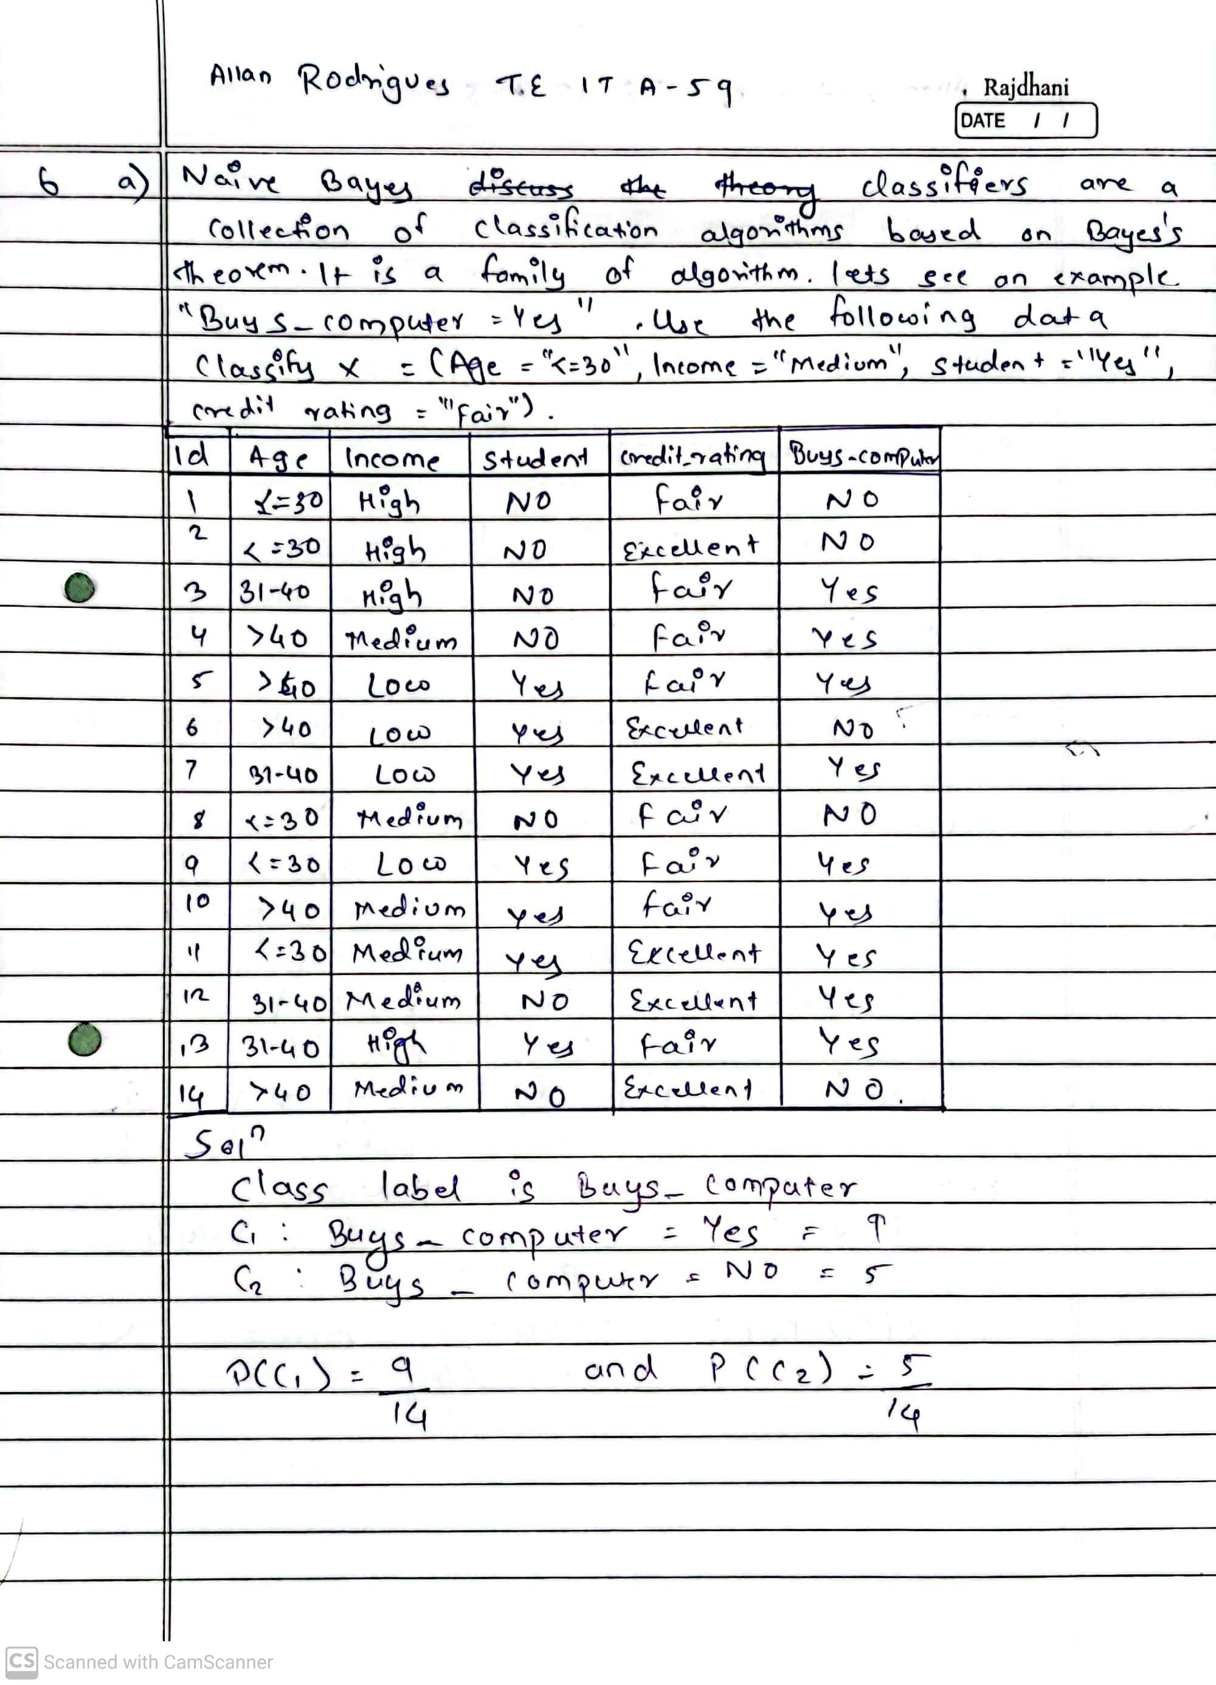

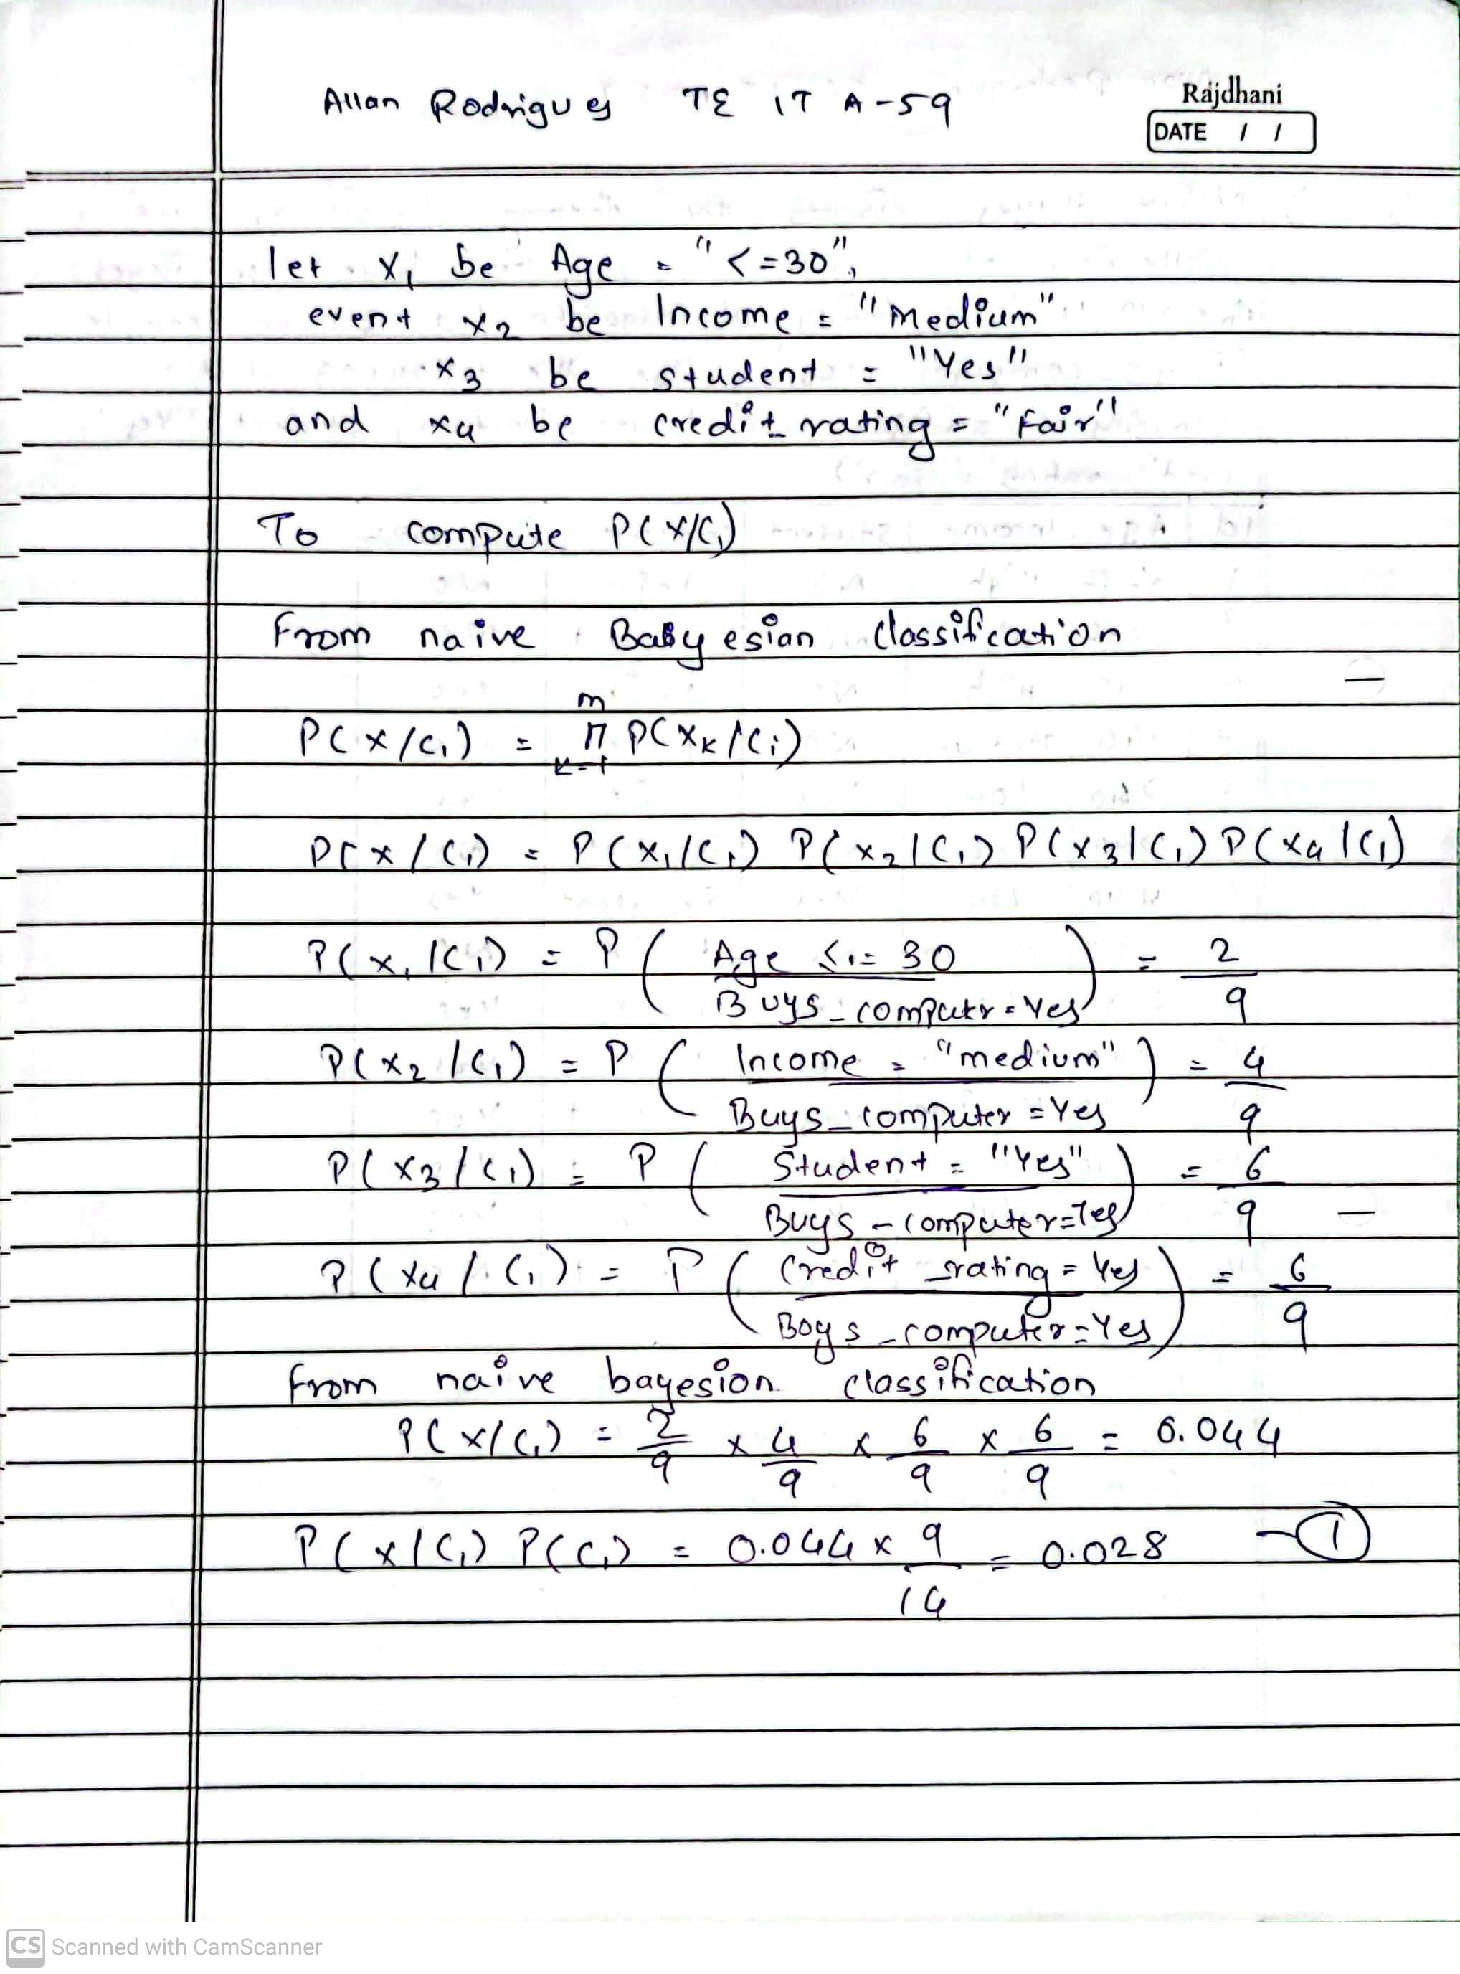

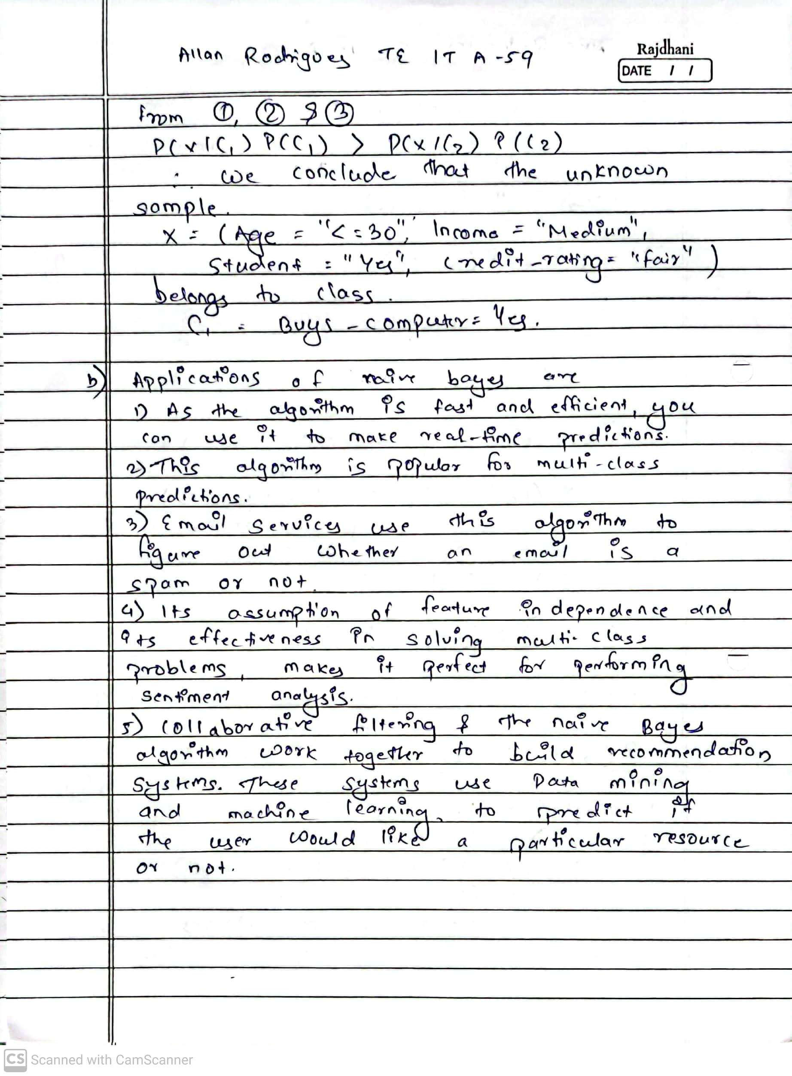

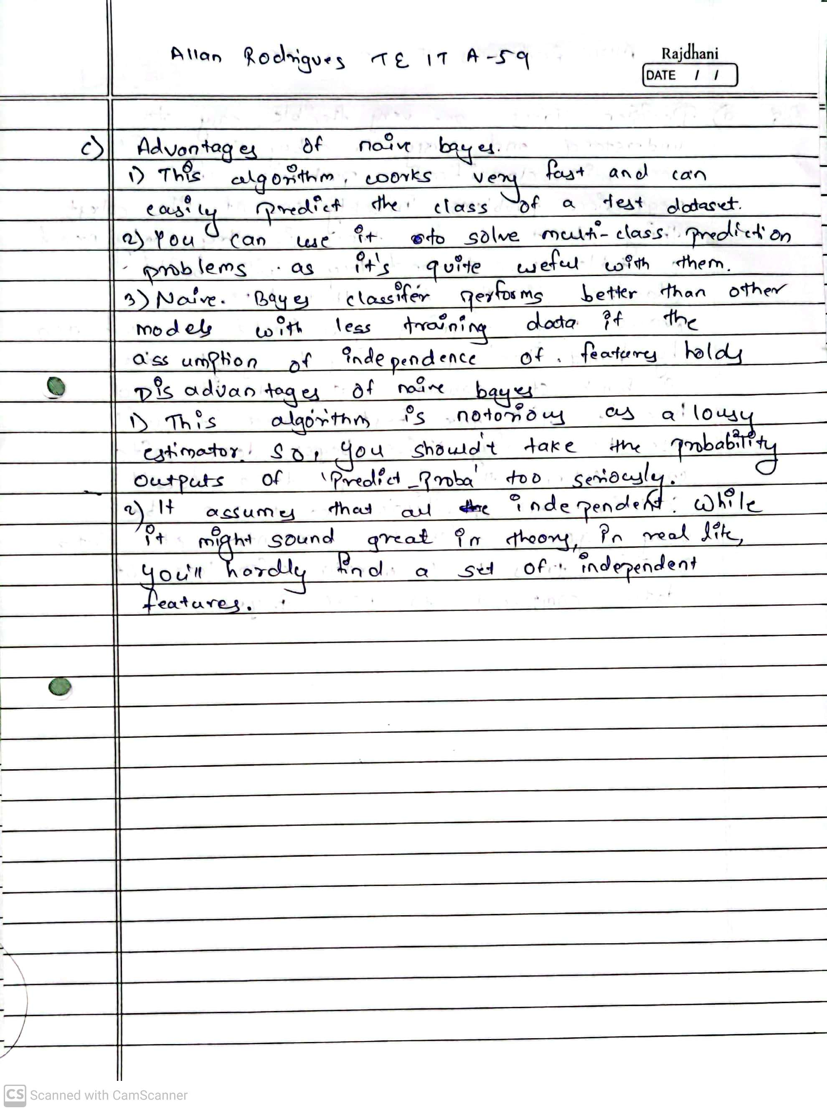

1. **Laboratory Exercise: Implementation of Classification Algorithm using JAVA/ R/ Python. Printout of implementation along with coding and Output.**

**Dataset:**

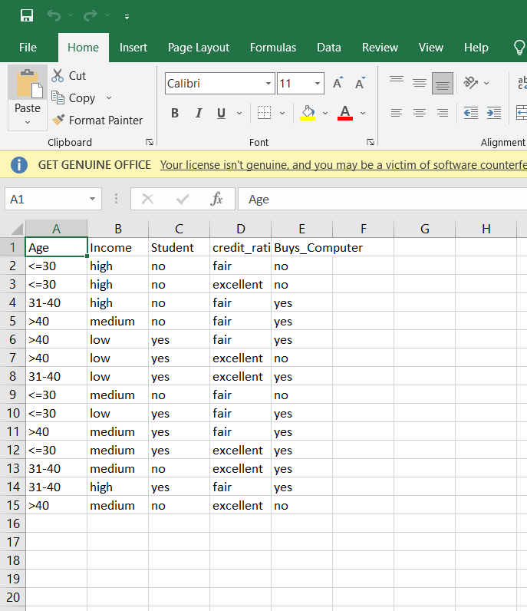

Code:

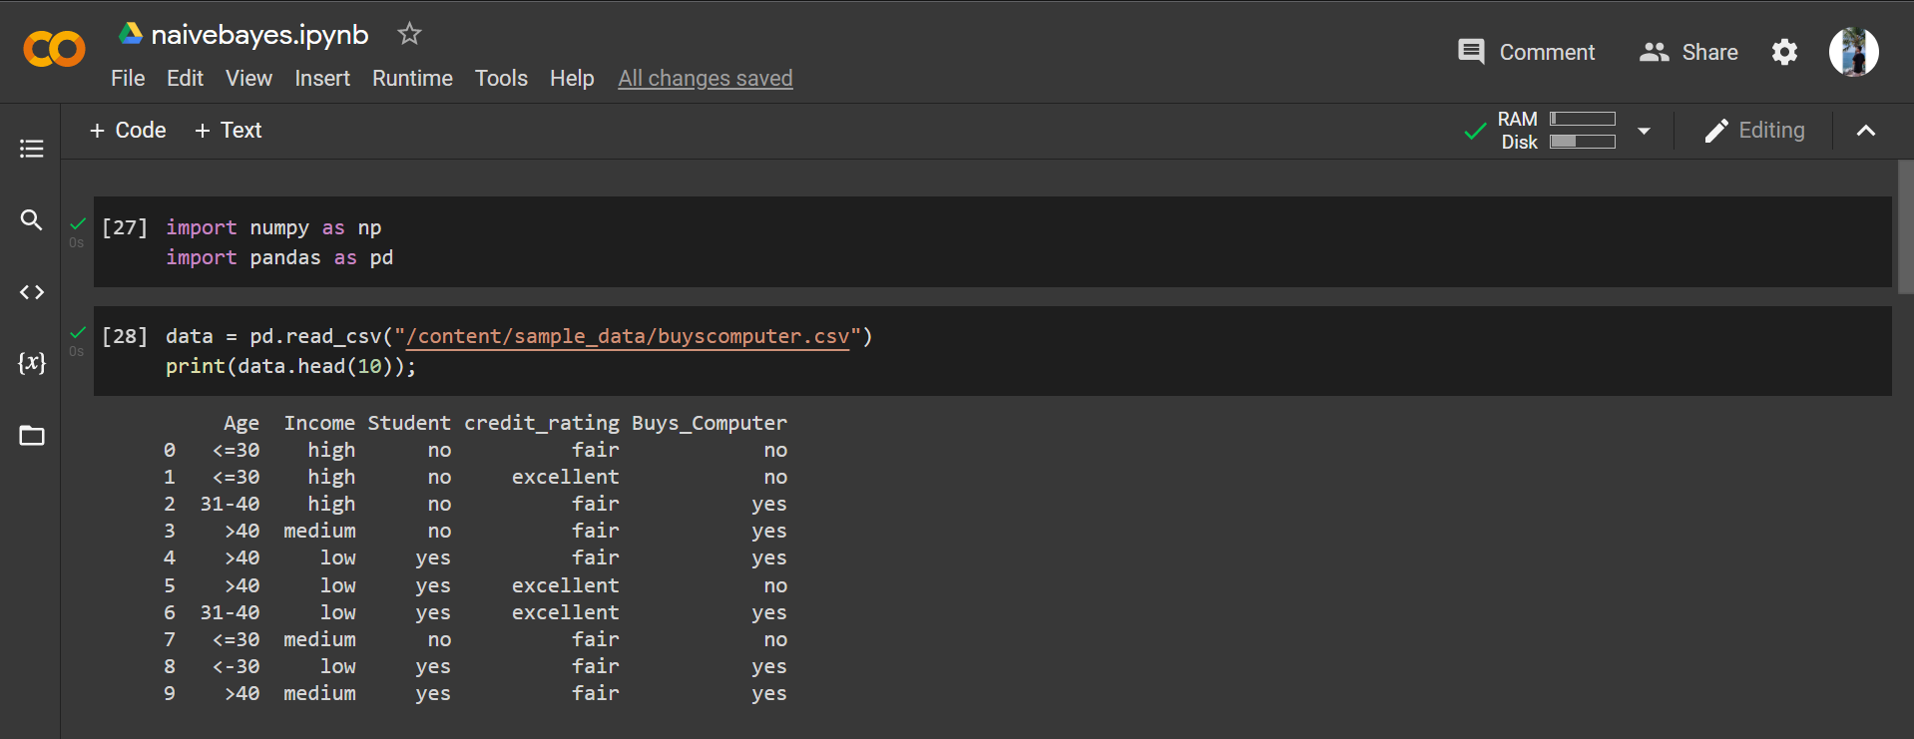

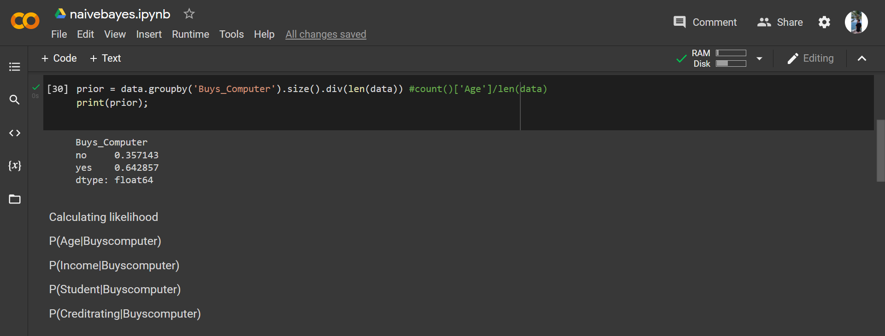

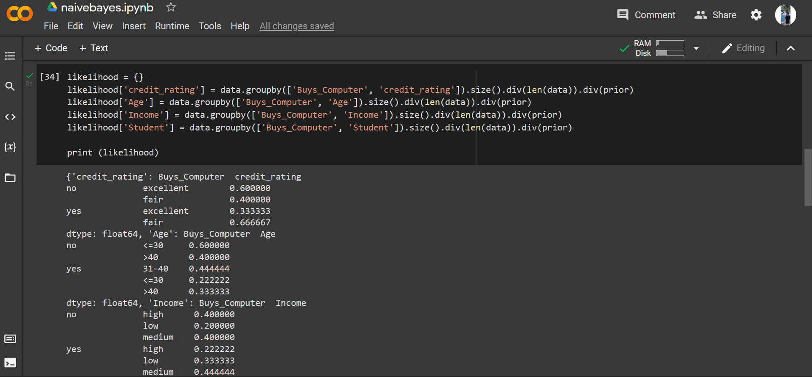

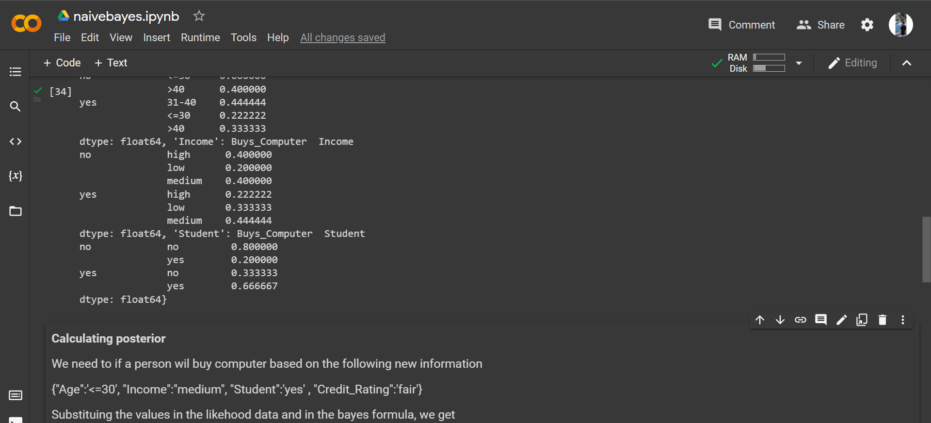

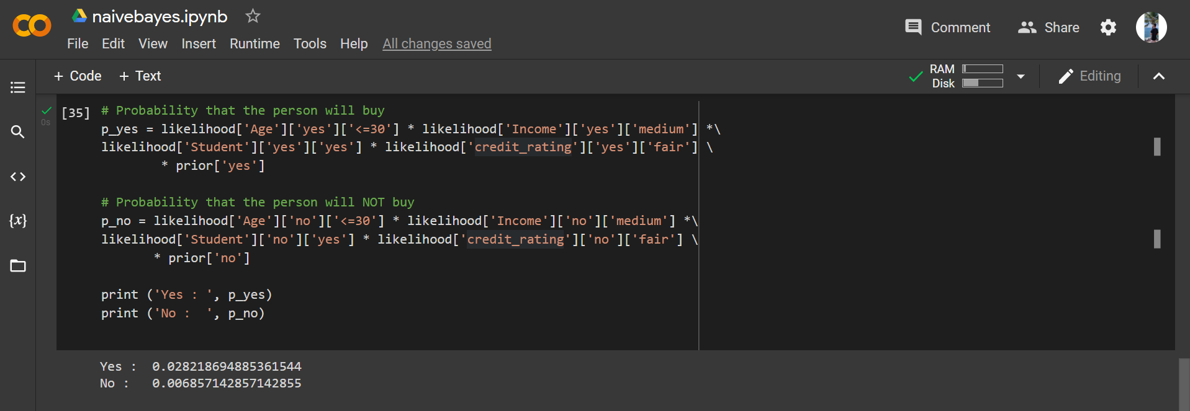

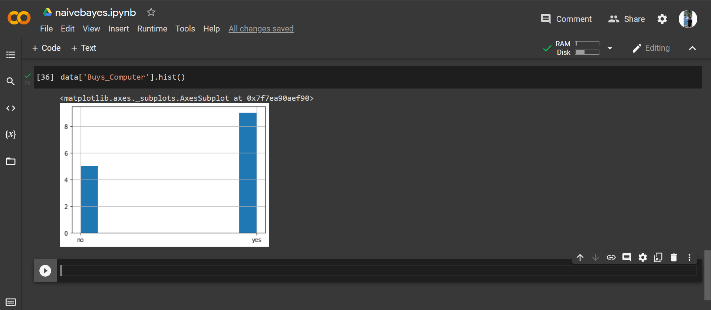

1. **Post-Experiments Exercise**
   1. **Questions:**
      * **Compare and Contrast between Decision Tree & Naïve Bayes**

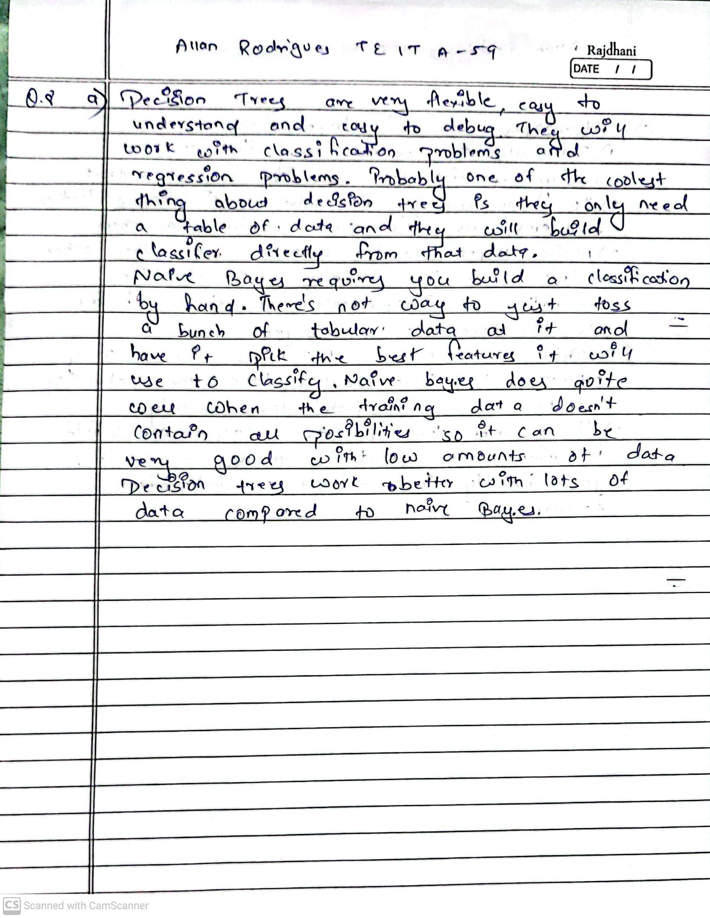

* 1. **Conclusion:**
     + **Summary of Experiment**
     + **Importance of Experiment**
     + **Application of Experiment**

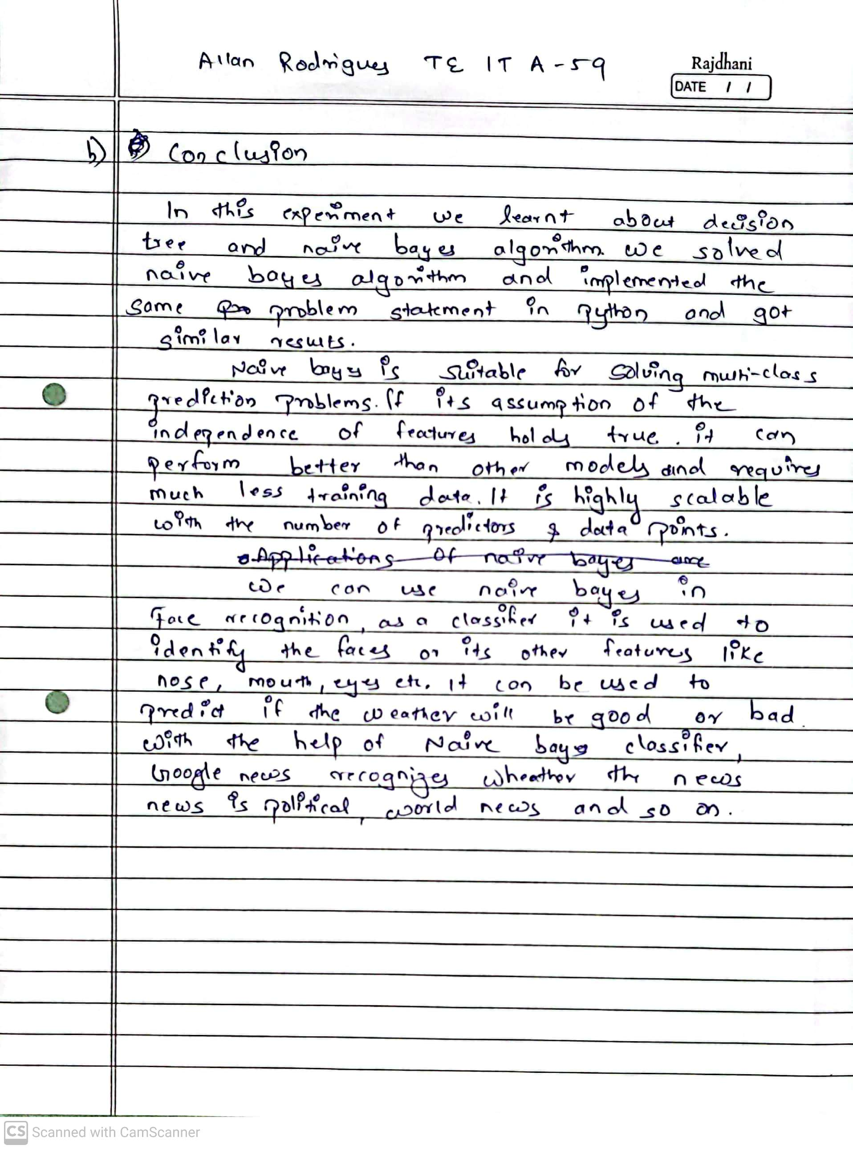

1. **Reference: Data Mining: Concept & Techniques, 3rd Edition, Jiawei Han, Micheline Kamber, Jian Pei, Elsevier.**

Reference links:

* [**h ttps://scikit-learn.org/stable/modules/naive_bayes.html**](https://scikit-learn.org/stable/modules/naive_bayes.html)
* [**h ttps://www.datacamp.com/community/tutorials/naive-bayes-scikit-learn**](https://www.datacamp.com/community/tutorials/naive-bayes-scikit-learn)

·

<https://www.analyticsvidhya.com/blog/2021/11/implementation-of-gaussian-naive>

[-bayes-in-python-sklearn/](https://www.analyticsvidhya.com/blog/2021/11/implementation-of-gaussian-naive-bayes-in-python-sklearn/)

·

[https://github.com/2796gaurav/Naive-bayes-explained/blob/master/Naive%20bay](https://github.com/2796gaurav/Naive-bayes-explained/blob/master/Naive%20bayes/Naive%20Bayes%20in%20scikit%20learn.ipynb)

[es/Naive%20Bayes%20in%20scikit%20learn.ipynb](https://github.com/2796gaurav/Naive-bayes-explained/blob/master/Naive%20bayes/Naive%20Bayes%20in%20scikit%20learn.ipynb)

* [https://www.upgrad.com/blog/naive-bayes-classifier/](https://www.upgrad.com/blog/naive-bayes-classifier/#:~:text=Applications%20of%20Naive%20Bayes%20Algorithm,-As%20you%20must&text=As%20this%20algorithm%20is%20fast,easily%20by%20using%20this%20algorithm.)

<https://stackoverflow.com/questions/10317885/decision-tree-vs-naive-bayes-classifier>

·